Scikit-image => import skimage

Snakes / Active contour model:
Contours based on shape inside a predefined zone of the image. The active contour model is a method to fit open or closed splines to lines or edges in an image. It works by minimising an energy that is in part defined by the image and part by the spline’s shape: length and smoothness. The minimization is done implicitly in the shape energy and explicitly in the image energy.

Spline
A spline consists of limited amount of consecutive patches, whereby each patch is described by a polynom (meaning that it is in the form c0+c1x+c2x2+...+cnxn). The patches have a fixed length and are continuous at the boundary of the patches (meaning that the polynom must start with the same value as at the end of the previous patch). The same property applies for certain splines (there are many different splines) for their derivatives.

Basics

when converting an image to grayscale (through k-means, PCA, or PIL image), you have to override the default color map, otherwise the colors will be merely inverted. This will also effectively convert the resulting numpy array from 3-dim to 2-dim
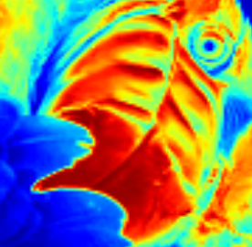
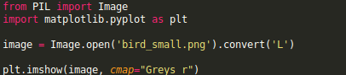
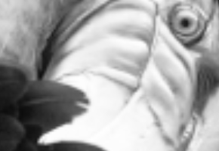

Create a thumbnail:

Where pil_im is the name of the image
Show image
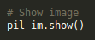
PIL coordinates system and cropping an image relative to size
PIL uses a 4-tuple coordinate system (a box coordinates are constituted of 4 numbers), the top left corner being (0,0), while (0,0,128,128) traverses an image of 128X128 (so box is defined by its diagonal)
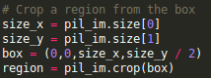

Matplotlib

Convert PIL image to numpy array
Allows to trace graphs, curves on the image and gives us axes as well
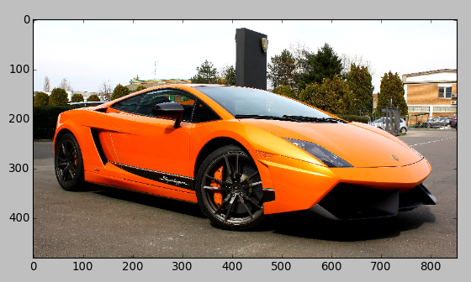
After loading the image with PIL:
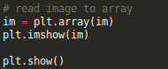

Plotting points and graphs
First, group some points together in lists
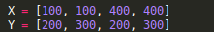
They need to be separated by x and y coordinates. Then, plot the points and trace lines between them if you need
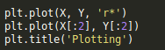

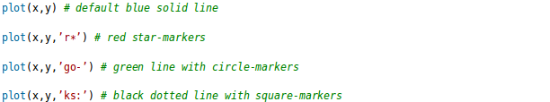
Finally, plt.subplot(241) takes 3 parameters (or 1, fusing 3 together), and defines the dimensions of the grid (3X4, 4th subplot etc). So when you are plotting several smaller images to be displayed at the same time (eg displaying written chars), this is a way to organize them.
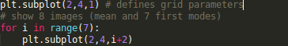
We see the first two param are dimensions and third is where the subimage is on the grid
Create contours of image:
First make sure the image is in grayscale
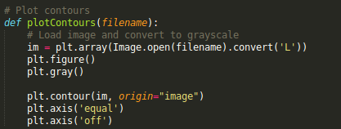

Create histogram for image:
a histogram can reveal how many pixels are in a bin (or in a color/grey-intensity, hence the x-axis is 0-255)
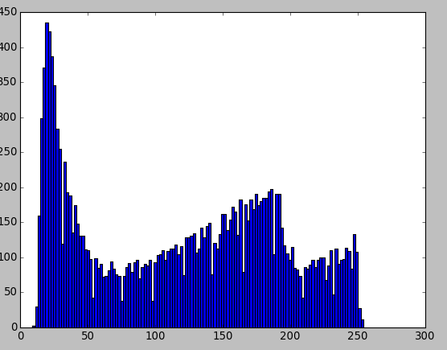
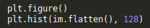

Notice that the image needs to be flattened first to a one dimensional array
Same program with 64 bins instead will give the following histogram

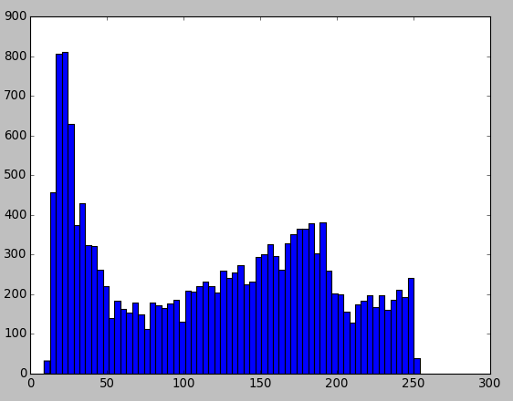

Numpy

Basically, when we convert a grayscale PIL image to a np array, each one of the pixels in the array is assigned a 8-bit value, representing the instensity of gray at that pixel (closer to 255, closer to white)
Inverting colors
Colors can be inverted easily with just a substraction

Visualization of how these transformations work:
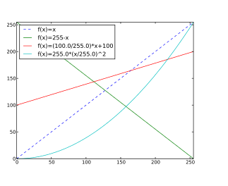

When applied (as they often are) to grayscale images, we call these functions graylevel transform functions
Changing back to image:

If that doesn't work because you modified the array,

There is no simple way to resize arrays, so its better to proceed to resizing before turned into numpy array

Histogram equalization
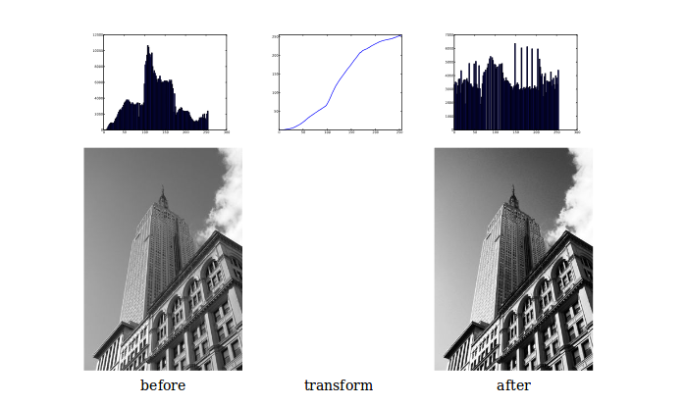
the middle plot is the graylevel transform function. We do that to make sure all intensities are as equally common as possible

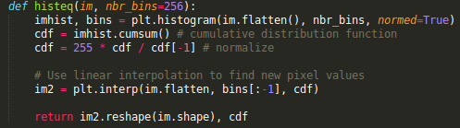

Averaging Images
In the same way, averaging an image is a simple way of reducing an image noise
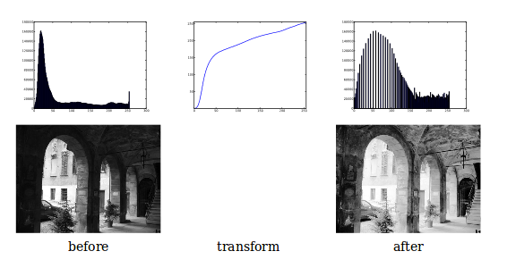
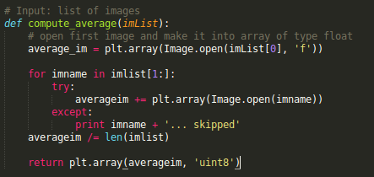

PCA of images:
This function first centers the data by subtracting the mean in each dimension. Then
the eigenvectors corresponding to the largest eigenvalues of the covariance matrix
are computed, either using a compact trick or using SVD. Here we used the functionrange()
which takes an integer n and returns a list of integers 0..(n1). Xrange is different from range in that it is a generator, and may be faster
.
Lists all files in a directory and puts them in a list
This:

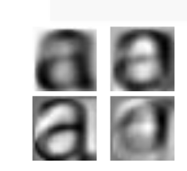

We took all images, computed their mean, covar and eigenvalues, and returned the directions with most variation (the fours letters just above are the mean and the three first eigenvectors)

Pickle

pickle takes almost any python object and transforms it into a string representation (process is called pickling)
What is more interesting for us is the process of unpickling
Pickling
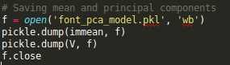

Loading Pickle
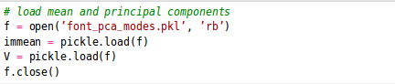

SCIPY

Scipy is an open source package for mathematics built on numpy

Blurring images

Blurring images is simply convolving them with a gaussian kernel. If I is the image and G is the Kernel(x_direction, y_direction)
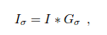

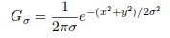

Gaussian blurring is used to define an image scale to work in, for interpolation, for
computing interest points, and in many more applications

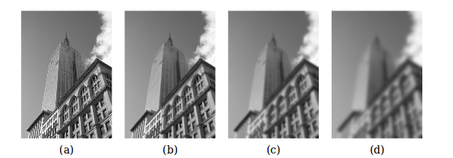
Effects of increasing sigma; Larger values give less detail

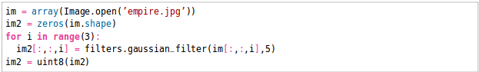
Blurring color images. We simply iterate over the third dimension of the array (each color channel). uint8(im2) ensure we stay in an 8-bit representation for the pixel values (all values in 0-255 range)

Image derivatives
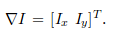
image gradient:

x and y are directions (mainly horizontal and vertical)
Because of the nature of matrix multiplication, we can deduce that:
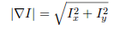

(gradient magnitude)

And, as any derivative, this describes a change, in this case how strong the image intensity change is.

The gradient angle alpha describes the direction of the largest intensity change at each point in the image
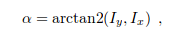

alpha is an angle in radians (cf transition from cartesian to polar coordinates)
Think transition from cartesian to polar coordinates when talking about gradient of an image

Computing Ix and Iy is commonly done with Prewitt filters and Sobel filters
(two sets of matrices)
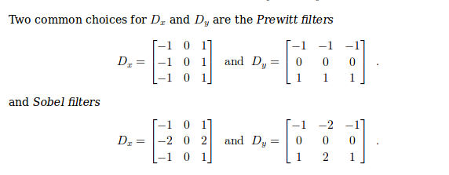
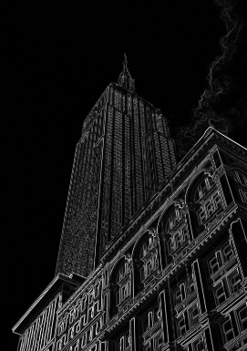

gradient magnitude of an image, useful for outliners and edge detection

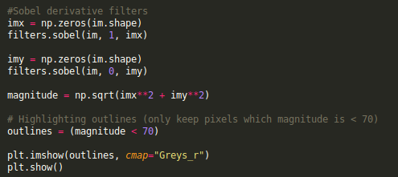
This gives:
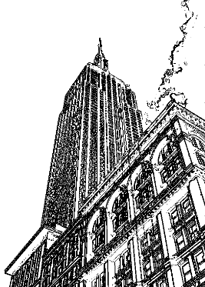

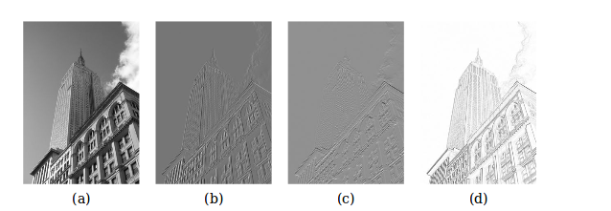
grayscale, x-derivative, y-derivative and gradient magnitude

Resorting to gaussian transformation instead to compute gradient has the advantage to be more robust to image noise

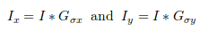

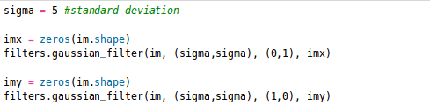

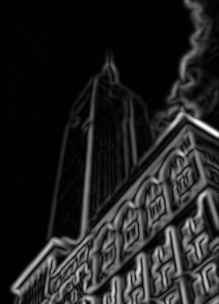
gradient magnitude using a gaussian filter instead of a sobel filter. Smoother around the edges.

The third argument specifies which order of derivatives to use in each direction using
the standard deviation determined by the second argument.

Morphology – counting object

theory and technique for the analysis and processing of geometrical structures.
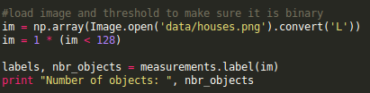

(result 45 objects)
Counts the objects on the image. Make sure the image is in binary. Multiplying with
1 converts the boolean array (im < 128 gives boolean) to a binary one

If there are small connections between the objects which may falsify results, use binary openings function
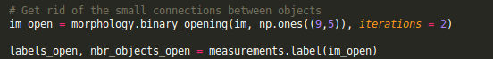
(result 48 objects)

np.ones((9,5)) specifies the structuring element, an array that indicates what neighbors to use when centered around a pixel. In this case, we used 9 pixels (4 above, the pixel itself, and 4 below), and 5 in the x-direction

Image De-noising

We will use Rudin-Osher-Fatemi denoising model (ROF).
We define the total variation of an image as the continuous sum of the gradient norm:
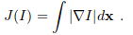

Which gives, in a discreet setting:
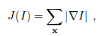

where X = [x,y]

We also define U as our parameter, the denoised image

We are trying to minimize the euclidean norm between I and U (original and denoised image) with a regularization term E:

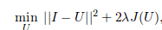

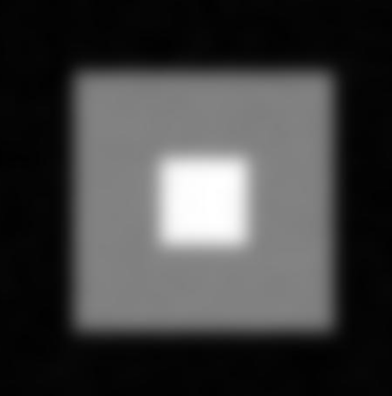
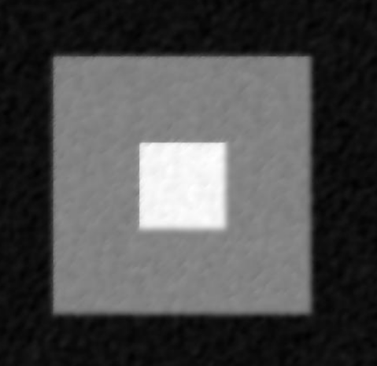

=======>

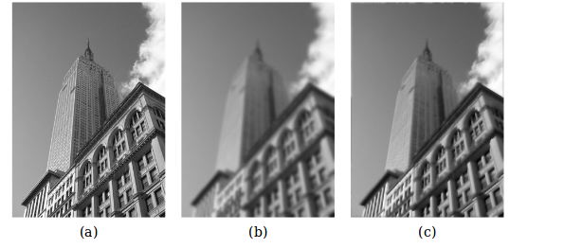
Think of it as a nicer blur, as it preserves the edges, while reducing the noise (c)

Using self quotient image to normalize:
apply blur to image and divide original image by blur:

